**Setting up Spark with Maven**

Apr 2, 2015 • Written by [David Åse](https://www.linkedin.com/in/davidaase) • Spark Framework Tutorials

<https://sparktutorials.github.io/2015/04/02/setting-up-a-spark-project-with-maven.html#eclipse>

**IDE Guides**

[- Instructions for IntelliJ IDEA](https://sparktutorials.github.io/2015/04/02/setting-up-a-spark-project-with-maven.html#intellij)  
[- Instructions for Eclipse](https://sparktutorials.github.io/2015/04/02/setting-up-a-spark-project-with-maven.html#eclipse)

**About Maven**

Maven is a build automation tool used primarily for Java projects. It addresses two aspects of building software: First, it describes how software is built, and second, it describes its dependencies.

Maven projects are configured using a [Project Object Model](https://en.wikipedia.org/wiki/Apache_Maven#Project_Object_Model), which is stored in a pom.[xml](https://en.wikipedia.org/wiki/XML)-file.   
Here’s a minimal example:

<project>

<!-- model version - always 4.0.0 for Maven 2.x POMs -->

<modelVersion>4.0.0</modelVersion>

<!-- project coordinates - values which uniquely identify this project -->

<groupId>com.mycompany.app</groupId>

<artifactId>my-app</artifactId>

<version>1.0</version>

<!-- library dependencies -->

<dependencies>

<dependency>

<groupId>com.sparkjava</groupId>

<artifactId>spark-core</artifactId>

<version>2.2</version>

</dependency>

</dependencies>

</project>

**Instructions for IntelliJ IDEA**

Click “File” and select “New project…”: 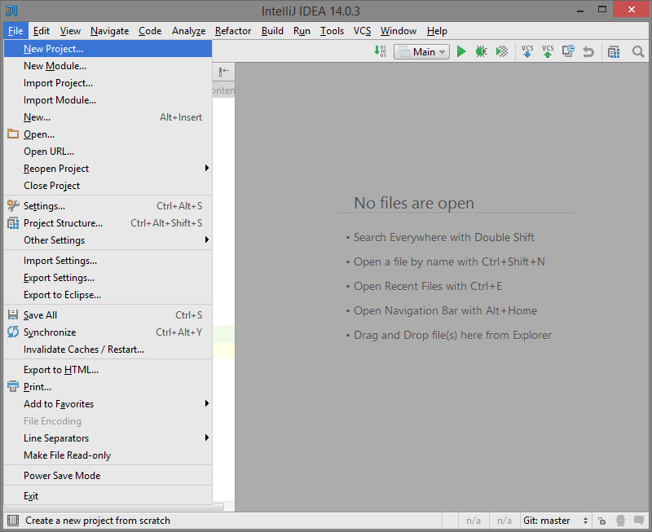

Select “Maven” on the left hand menu and click “Next”: 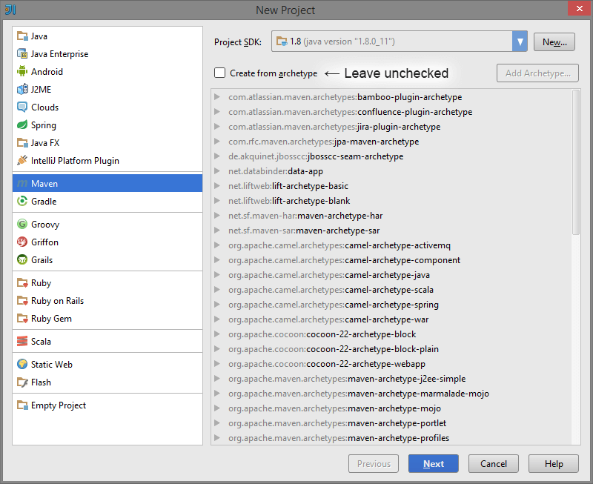

Enter GroupId, ArtifactId and Verison, and click “Next”: 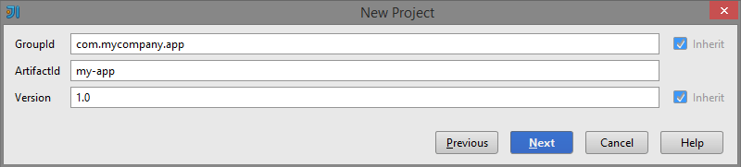

Give your project a name and click “Finish”: 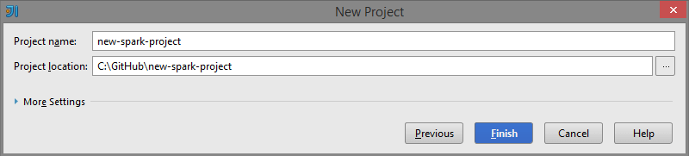

Paste the Spark dependency into the generated pom.xml. If prompted, tell IntelliJ to enable auto-import. 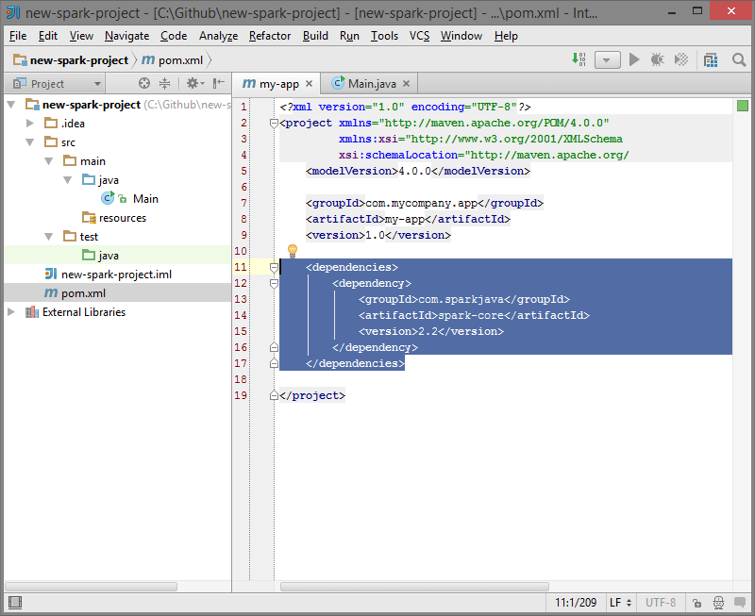

<dependencies>

<dependency>

<groupId>com.sparkjava</groupId>

<artifactId>spark-core</artifactId>

<version>2.2</version>

</dependency>

</dependencies>

Finally, paste the Spark “Hello World” snippet:

import static spark.Spark.*;

public class Main {

public static void main(String[] args) {

get("/hello", (req, res) -> "Hello World");

}

}

Into a new Class, “Main.java”: 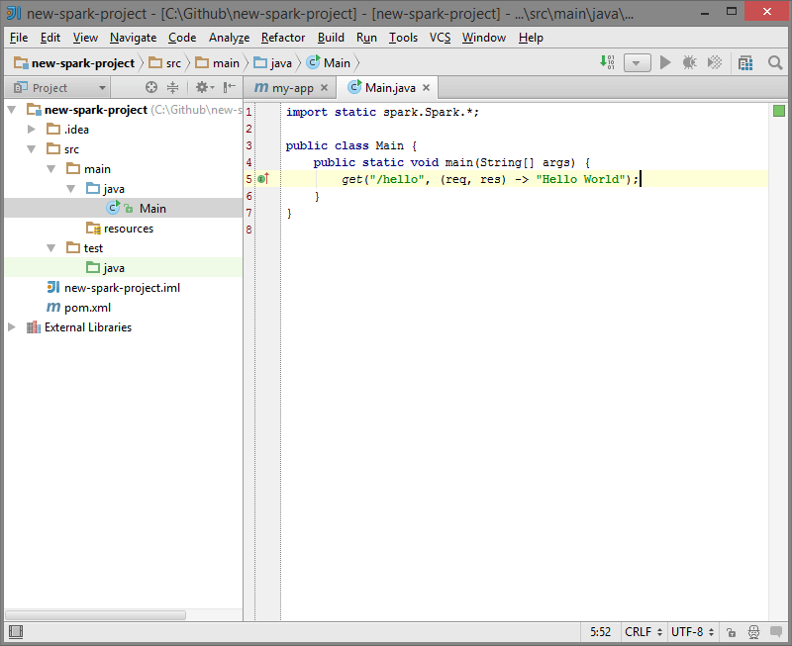

Now everything is ready for you to run your main Class. Enjoy!

*If IntelliJ says* ***"Method references are not supported at this language level"****,   
press* ***alt+enter*** *and choose* ***"Set language level to 8 - Lambdas, type annotations, etc."****.*

**Instructions for Eclipse**

Click “File” and select “New” then “Other…”: 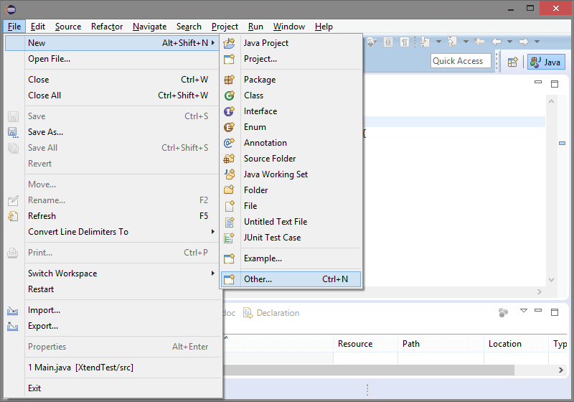

Expand “Maven” and select “Maven Project”, then click “Next”: 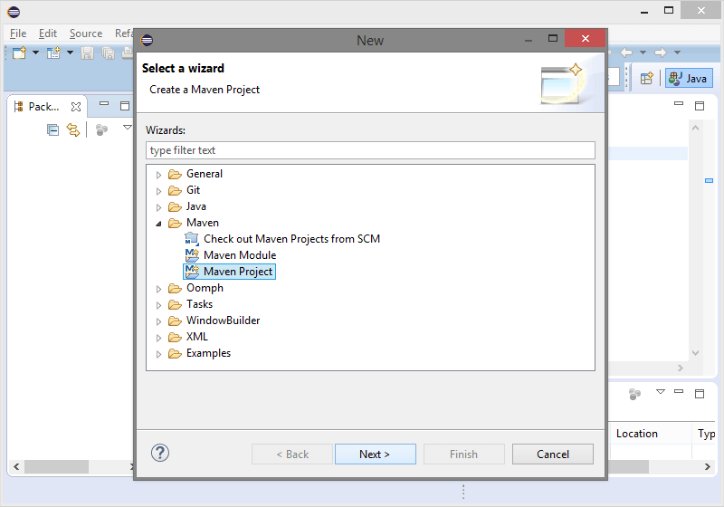

Check the “Create a simple project” checkbox and click “Next”: 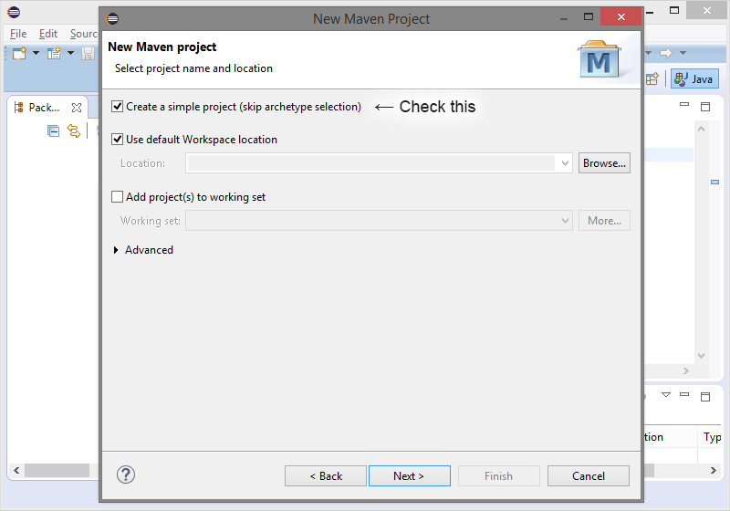

Enter GroupId, ArtifactId, Verison, and Name, and click “Finish”: 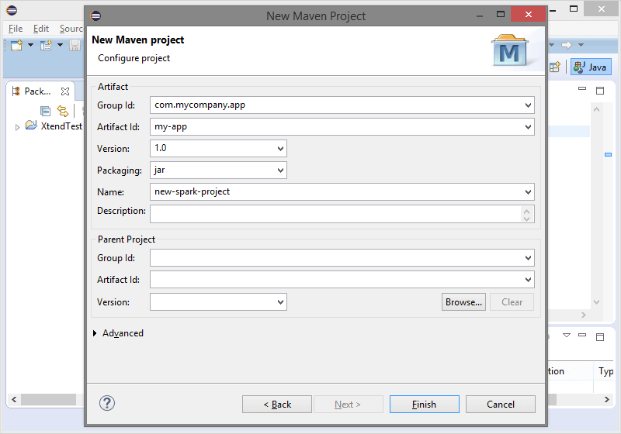

Open the pom.xml file and click the “pom.xml” tab. Paste in the Spark dependency: 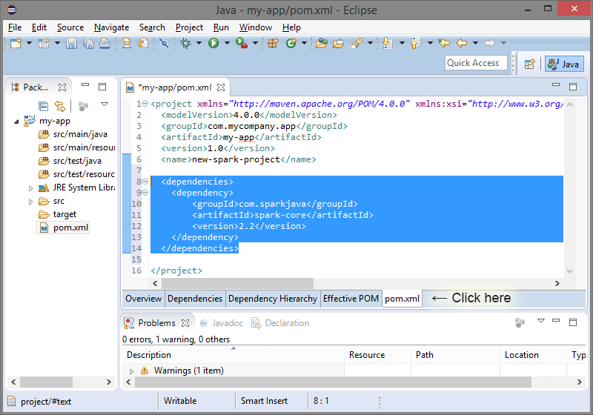

<dependencies>

<dependency>

<groupId>com.sparkjava</groupId>

<artifactId>spark-core</artifactId>

<version>2.2</version>

</dependency>

</dependencies>

**Save the pom.xml file!**

Finally, paste the Spark “Hello World” snippet:

import static spark.Spark.*;

public class Main {

public static void main(String[] args) {

get("/hello", (req, res) -> "Hello World");

}

}

Into a new Class, “Main.java”: 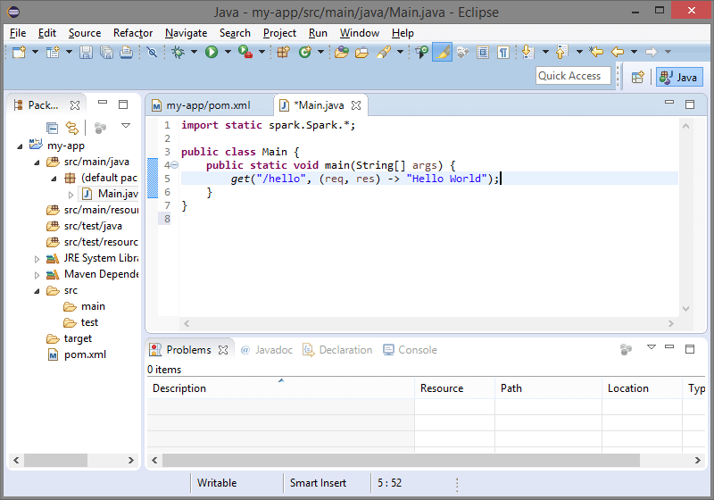

Now everything is ready for you to run your main Class. Enjoy!